Setup Using a Web Browser
To perform setup using a web browser, connect to the Unleashed setup network using any Wi-Fi capable client device.
- Using your the Wi-Fi configuration settings on your client device (such as a laptop or mobile device), select and associate to the Configure.Me-[xxxxxx] WLAN, and launch a web browser.
- In your browser's URL bar, enter the following address and press Enter: unleashed.ruckuswireless.com.
Figure 1
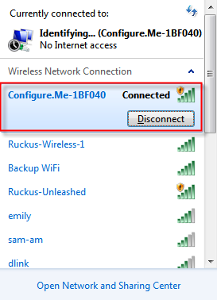
NOTES: Option available if the unleashed.ruckuswirless.com didn't work
Is taking the IP address of the access points of the router configuration (many times identify the access points in the router list as ruckus-unleashed or unknown) and pasting in the URL bar
How do I access to my router settings? Please check the link below
https://www.hellotech.com/guide/for/how-do-i-find-my-router-ip-address
- Depending on your browser, you may be presented with a security warning saying "This connection is not trusted" (Firefox) or "Your Connection is Not Private" (Chrome) or "There is a problem with this website's security certificate" (Internet Explorer). This is normal, as the Unleashed AP does not have an SSL certificate that is recognized by your browser.
- Click Advanced > Proceed to [IP address] (unsafe) (Chrome), or I Understand the Risks > Add Exception... > Confirm Security Exception (Firefox), or Continue to this website (not recommended) (IE) to continue.
FIGURE 2 Security warning (Chrome)

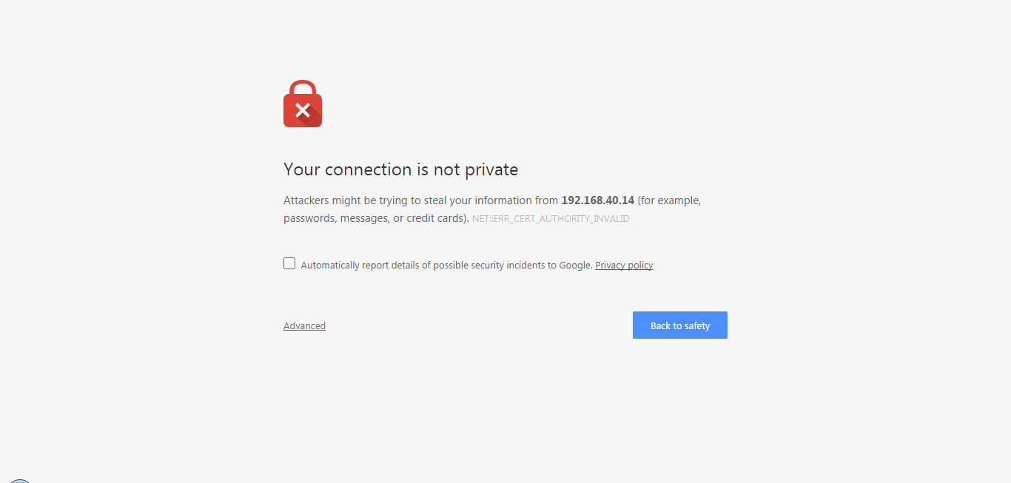
- You will be redirected to the Setup Wizard, which guides you through the process of setting up the Unleashed Master AP.
- Work through the Setup Wizard and check your configuration choices on the final page, before clicking Finish to complete the setup.
  - On the first page of the wizard, "System", select your Language from the menu.
  - Enter a System Name for the Unleashed system. This system name can be used to identify the Unleashed device on your local area network.
  - Select your Country Code from the menu.
NOTE
This option is not displayed if the AP is shipped from the factory with a fixed country code.
  - Please do not enable mesh (For Lennar environment).
NOTE
If the Unleashed AP does not support Mesh (e.g., R310), it can be configured as the Unleashed Master, but it will not be able to participate in the mesh network.
  - Click Next to continue.
FIGURE 3 Setup Wizard 1
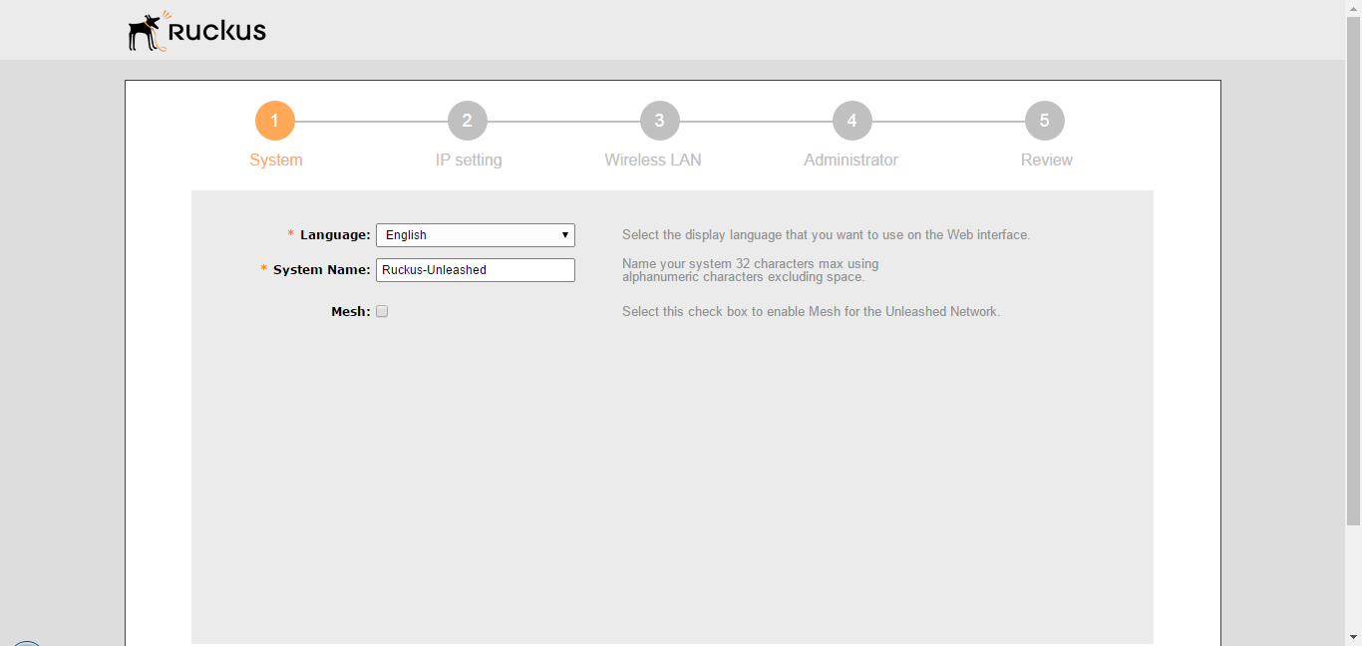
  - On the IP Setting page, select whether the AP will serve as a Gateway using one Ethernet port as a WAN port (connected to a cable modem, PPPoE connection, etc.) and the other as a LAN port.
NOTE
If your modem/router already provides gateway functionality, do not enable Gateway mode on the Unleashed Master AP. For more information on Gateway mode, see Gateway Mode.
  - Select whether to assign a manual IP address or allow the system to obtain an IP address automatically using DHCP. Default is Dynamic (DHCP).
NOTE
If you plan to manually assign and maintain IP addresses for your wireless network then select Static (Manual) and enter your Unleashed Master AP's IP address. Ensure that the IP address is outside the range assigned for Wi-Fi clients. Otherwise, leave the default of Dynamic (DHCP) and let Unleashed do all the work for you.
  - If you choose Manual, enter an IP Address, Netmask, Gateway address and DNS server(s) in the fields provided.
NOTE
Optionally, if a manual IP address is configured, you can enable the built in DHCP Server to provide IP addresses to clients on Unleashed's own subnet. (For more information, see DHCP Server)
FIGURE 4 Setup Wizard 2
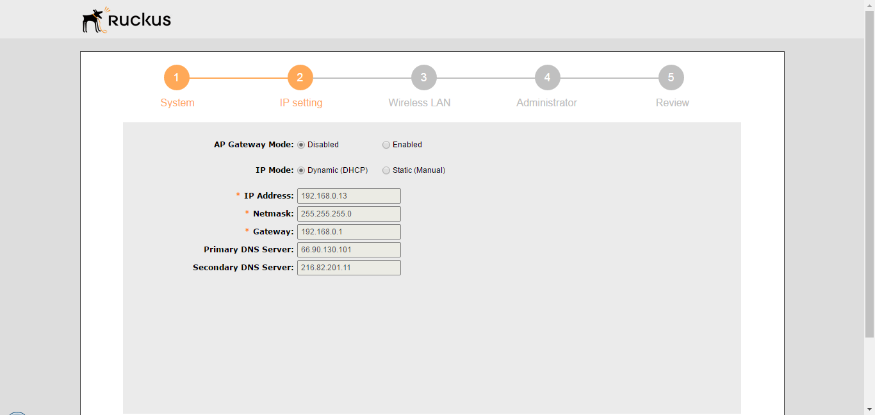
  - Click Next to continue.
  - On the Wireless LAN page, clear the text box and enter a Name for your first wireless LAN.
  - Select an Encryption Method (Open or WPA2).
NOTE
WPA2 is highly recommend for the highest level of security.
  - If WPA2 encryption is selected, enter a Password consisting of 8-63 alphanumeric characters.
  - Click Next to continue.
FIGURE 5 Setup Wizard 3
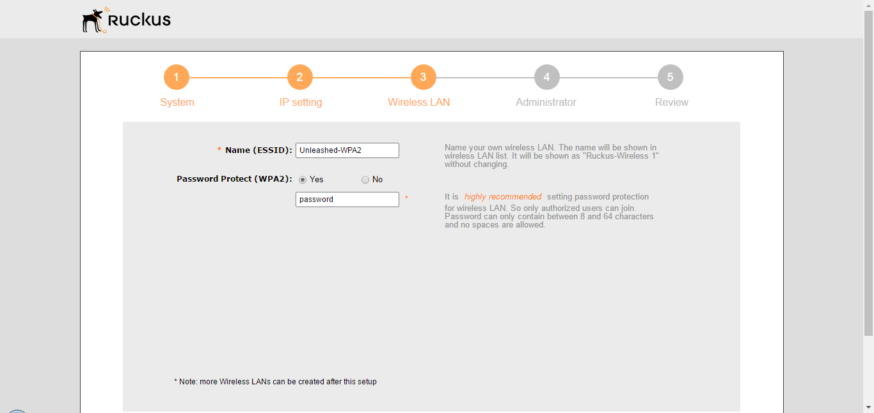
  - On the Administrator page, enter an Admin Username and Password.
  - Re-enter the password in Confirm Password.
  - Optionally, enter a Security Email, Security Question and Security Answer to allow you to reset your password in the event that your username or password are forgotten.
  - Click Next to continue.
FIGURE 6 Setup Wizard 4
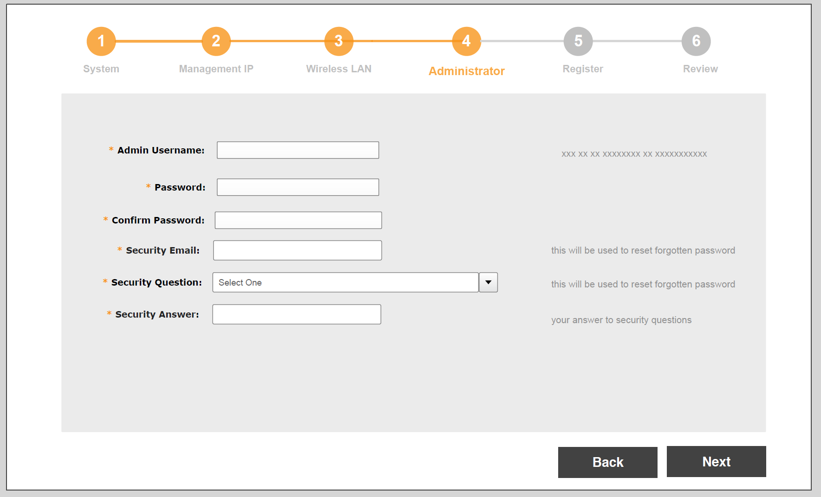
  - On the Review page, check that all the settings you have made are correct. If any settings need to be changed, click Back to go back to the previous wizard page.
  - If you are satisfied with your choices, click Finish to complete the setup.
FIGURE 7 Setup Wizard 5
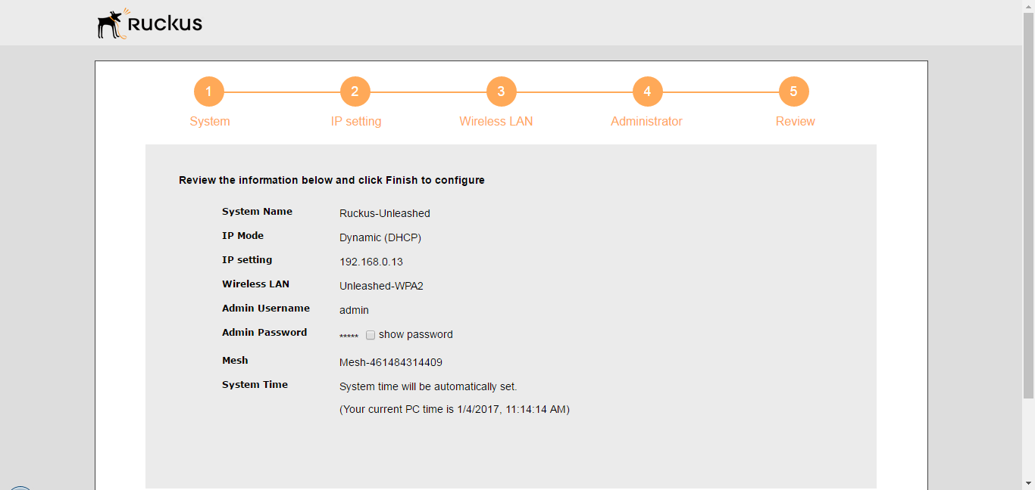
- After clicking the Finish button, the Unleashed Master AP will reboot and a "Configuring system settings & rebooting" page is displayed. Wait for the progress screen to complete before proceeding.
NOTE
Do not disconnect power or network cables during this process, and do not click your browser's Back or Refresh buttons.
FIGURE 8 Configuring system settings and rebooting progress screen
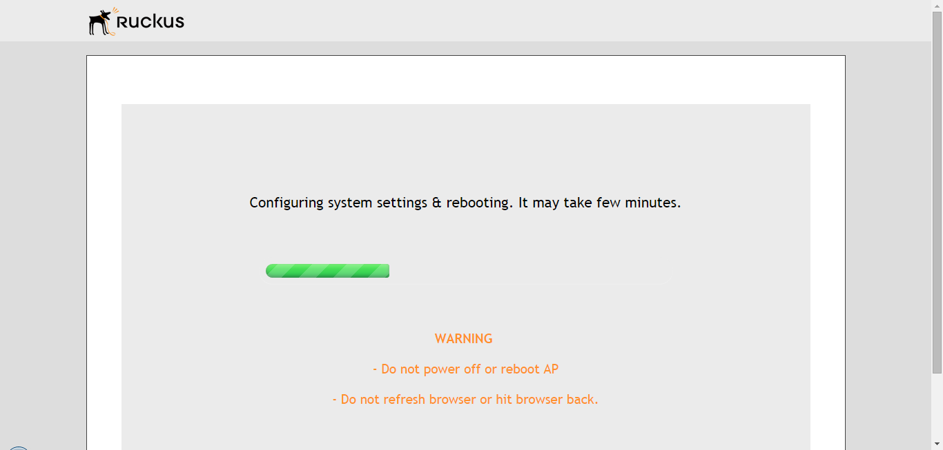
- After setup is complete, the "Congratulations!" screen appears. Ensure that you are connected to the WLAN you configured, then click Finish. You will be redirected to the login page.
FIGURE 10 "Congratulations! Unleashed Master is now configured" screen
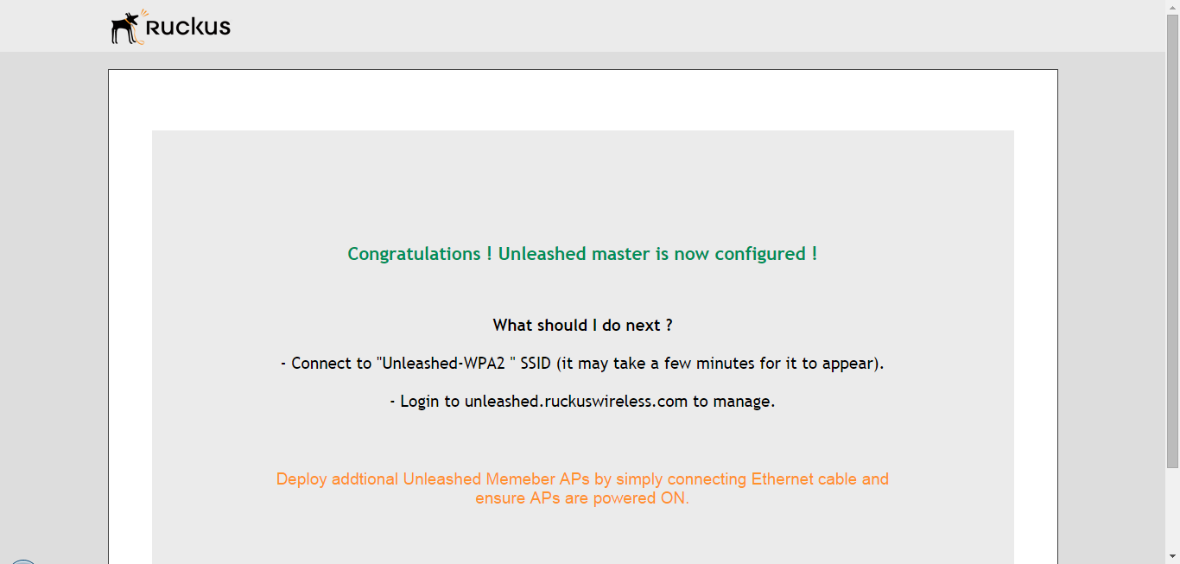
- Enter your User Name and Password, and click Unleash to login.
FIGURE 11 Login screen
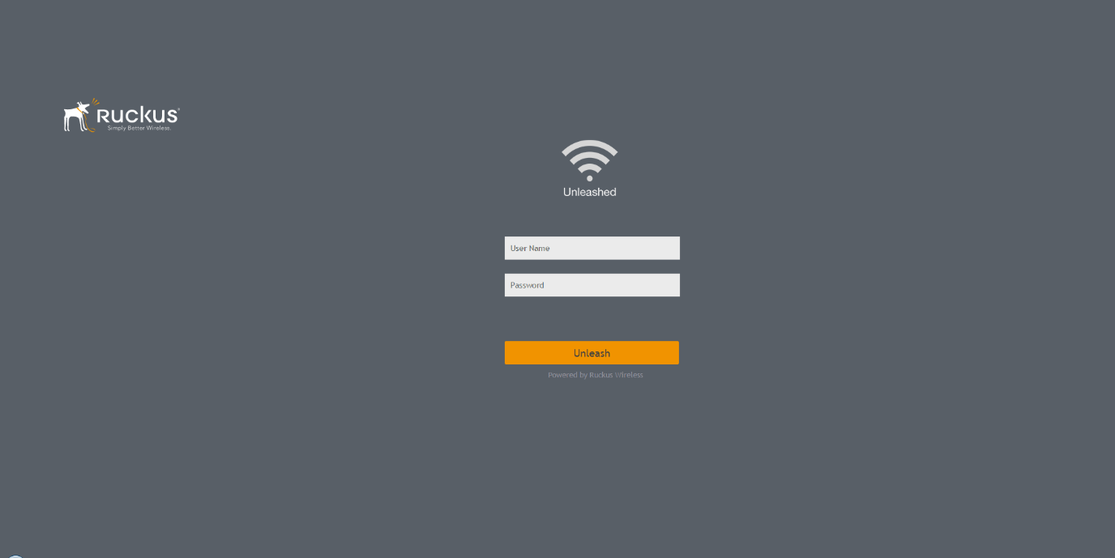
- After successful login, you will be presented with the Unleashed Dashboard, which displays an overview of your Ruckus Unleashed network.
FIGURE 12 Unleashed Dashboard
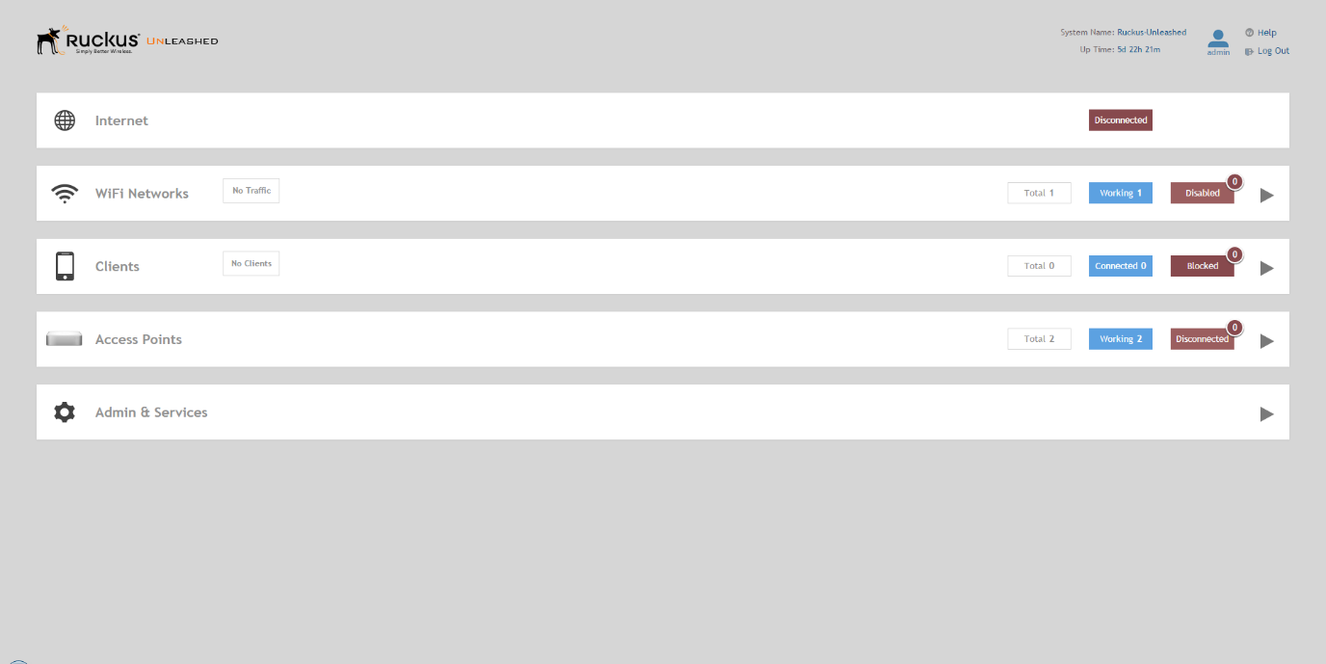
- Continue to Step 3: Customize Your Wireless LANs
NOTE
The first time that you log into the Unleashed Admin Interface, you will be presented with a Register screen, prompting you to register your Unleashed Master AP with Ruckus. This registration is optional, and you can skip this step and register later if you prefer. Ruckus recommends that you register your Unleashed APs with us to assist in receiving updates and important notifications, and to make it easier to receive support in case you need to contact Ruckus for customer assistance. See Registration for more information.
FIGURE 13 The Registration page (optional) appears the first time you log in - Click Register to register now, or click Skip to skip this step and register later.
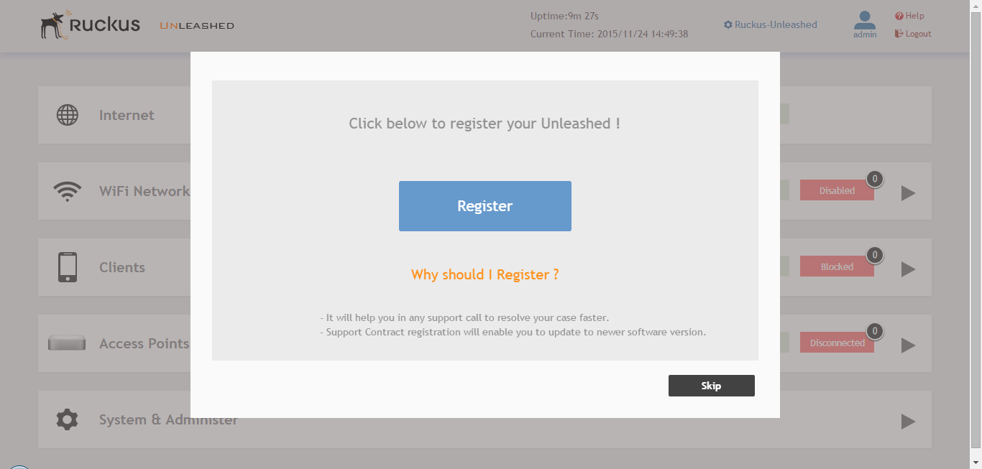

Original document:https://docs.ruckuswireless.com/unleashed/200.6/GUID-EF381E76-B12E-4EC6-AA72-30AF93A93306.html

